Student name: Jordan Elkin
Student ID: 226621873

SIT225: Data Capture Technologies

Activity 4.1: Collect GPS data using mobile apps

Mobile phones have significant sensing capabilities such as GPS, acceleration and lux. In this task you will use existing free mobile apps to record some GPS data.

Hardware Required
- A smartphone with GPS.

Software Required
A web browser
Either Android Geo Tracker (https://play.google.com/store/apps/detailsid=com.ilyabogdanovich.geotracker&hl=en )
Or iOS myTracks (https://itunes.apple.com/au/app/mytracks-the-gps-logger/id358697908?mt=8 )

You may install and try out any other app well as, as long as they can track GPS & export tracks to GPX format.

Steps:
Step | Action
1 | Track a journey using one of the installed mobile apps. It is best if your tracked journey spans at least 5 kilometers. Export your track to GPX format and save the file to your computer. Alternatively, you can email the .gpx file from your phone and download it to your computer  Question: Upload your .gpx file to a cloud storage (such as OneDrive) and share a public link here.  Answer:  https://github.com/jordanelkin/SIT225/blob/main/2026-08-02%2013_16_54.gpx
2 | Question: Open a browser on your computer and go to http://utrack.crempa.net/ . Upload your .GPX file to the site and click ‘Generate Report’. Take a screenshot and include it here.  Answer:  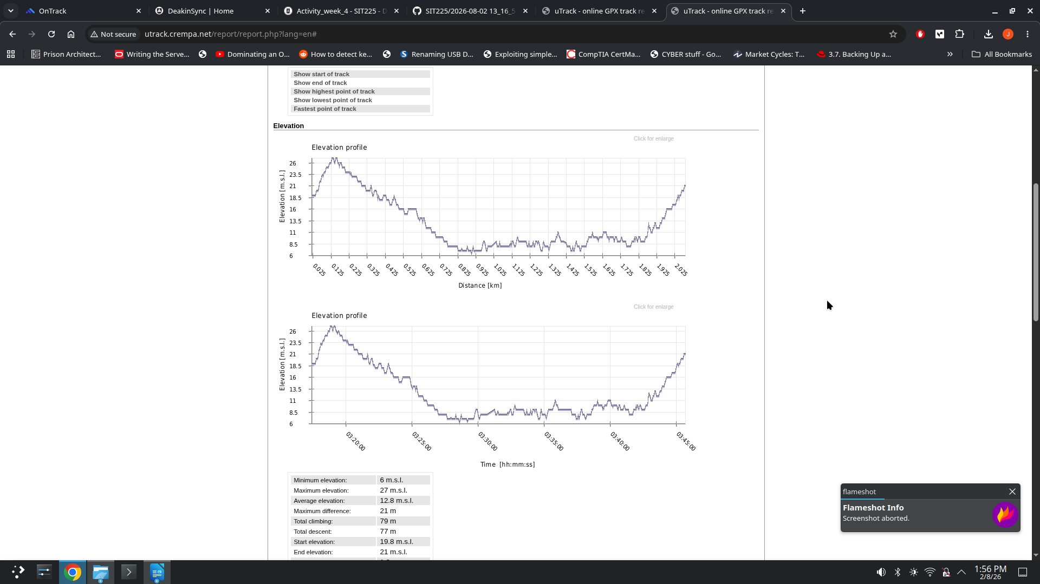
3 | Question: What information can you see from the generated report?  Note: Depending on the app you use to record the GPS data, timestamps could be either in local time (that is AEST if you are in Melbourne) or sometimes it could be in UTC.  Answer:  The generated report provides a view of the track on a map, it also shows the maximum elevation, minimum elevation, total climbing and descent, start times, end times and the pace over the entire track. It represents most if not all of this data as a line graph and also shows the averages of each.
4 | Question: Discuss in a group of 3 or 4 students to identify potential risks (more than one risk) if your data, which was collected by a service provider such as Google Map, was misused without your concern. Also suggest remedies - what kind of policies the service providers should adopt to mitigate these risks.  Answer:  If the data was collected by a service provider such as google maps it could equate your personally identifiable information such as your name registered via your google account with your geographic location. This information could provide cyber criminals the opportunity to know where you work, live, places you regularly visit. This could then also provide cyber criminals the opportunity to commit fraud or Impersonate you. Some strategies to mitigate these risks would be to de-identify the data with the users account, encrypt the data itself, or have a data retention policy where the data is deleted after a predetermined period of time.

Activity 4.2: The Ethics of Data Gathering
Digital privacy is top of mind for many Australians. With weekly data breach scandals, individuals are becoming more aware and concerned about who has their data, and more importantly, who controls how that information is gathered, used and shared. In this task, you will summarise a blog post regarding what should Australian businesses know regarding the ethics of data gathering.

Steps:
Step | Action
1 | Question: Study the web material which can be found here (https://www.insideinfo.com.au/business-intelligence-and-analytics/ethics-data-gathering-what-should-australian-businesses-know ). Discuss data legislation in Australia and (un)ethical use of customer data. Reflect your viewpoint.  Answer:  In Australia it is legal to collect customer information as long as the Australian Privacy Principles are being followed. However, this data must be directly related to your business’ use case and should be used to provide a better customer experience. In my opinion I believe that business’ should be able to collect de-identified information which may be used to provide a better experience to customers who opt-in. Although, this process should be transparent to all customers who opt-in, the storage and retention policy should be made available to customers before they opt-in to their data being collected. Further, customers should have the right to have their data deleted on request with sufficient evidence provided to them that this has occurred.

Activity 4.3: The ethical dilemma of self-driving cars
Self-driving cars are already cruising the streets today. And while these cars will ultimately be safer and cleaner than their manual counterparts, they can’t completely avoid accidents altogether. In this video, you will explore and reflect on how the car should be programmed if it encounters an unavoidable accident.

Steps:
Step | Action
1 | Question: Study the web material which can be found here (https://www.youtube.com/watch?v=ixIoDYVfKA0 ). Reflect critically the ethical considerations and discuss to what extent you agree or disagree with justification.  Answer:  I agree that self-driving cars may, in the future, provide a realistic way to reduce on road accidents and minimise risks to people traveling on the road. However, using self-driving cars will not be without error and accidents will still occur as was mentioned by the video. The video states the car must be programmed in such a manner to react to an accident by either sacrificing itself or others. Whilst this may seem straight forward that the car should not swerve and endanger others, many may people may have differing views on this scenario. Therefore, when the car is programmed different models may contain different biases depending on the programmer and the ethical model that they have built for themselves. I at this current point do not believe that a machine should be programmed to put others at risk nor should we be fully reliant on a self driving system as they are currently implemented. I also, think that no single company should be able to make decisions that have lasting, lifelong implications for other people that are not using their products themselves. It should at least, be presented to the government for regulation on how these vehicles should be programmed to react and should also be provided to the general public for their opinions and concerns to be raised.

Activity 4.4: The ethical dilemma of abusing generative language models
The use of generative language models such as ChatGPT is increasing in our daily life. A specific question can be asked in the chat-bot command prompt which generates related answers. Students often find the chat-bot a handy tool to ask any study related questions to get a direct answer and feels reluctant to search online and compile an answer by navigating through several websites. While the use of chat-bots are useful, their improper use can limit the students ability to learn. For example, using chat-bots to generate a direct answer to parts of an assignment should be avoided considering an ethical, as well as productive point-of-view.

Steps:
Step | Action
1 | Question: How you feel chat-bots (such as ChatGPT) should be used in the context of solving an assignment question? Reflect critically the ethical and learning considerations.  Discuss the question in a group of 3 to 4 students and share your and some of the other students’ thoughts that attracted your attention.  Answer:  Using chat bots that utilise generative pre-trained transformer technology is increasingly more common, and they are becoming evermore capable as the technology matures. They do create a lot of issues in the academic setting namely, students using the technology to plagiarise and complete work that they themselves should have completed. In the setting of an assignment it defeats the purpose of the assignment itself and also defeats the purpose of coming to university to learn in the first place if abused. This is because students would not actually be achieving any of the learning outcomes nor would they be able to demonstrate the skills they have allegedly spent years forming. However, this technology can also be used in a constructive, and beneficial manner and actually increase students knowledge and further their learning. This is because GPT models are able to provide feedback, spell checking, academic writing assistance and explain portions of assignments or lectures that a student may not have understood or may have had to wait until a lecturer or tutor was available to respond to them in the usual 2-3 business day period. There are other concerns as well such as what happens to the data that the students provide to the model and how it is used and stored. Further, it is unknown whether or not the models are providing the intellectual property of other people to others without attribution to the original creators.

